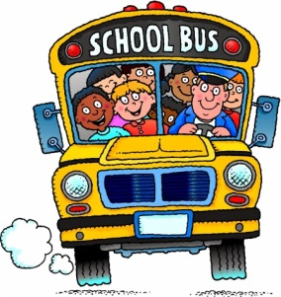
Mrs. LaPiana and Mrs. Adams
First Grade Supply List
2016-2017
- $7 for Scholastic News subscription (makes checks to Wakefield Elementary School or send cash)
- 1 composition notebook (black and white marbled cover – not spiral bound)
- 1 three ring binder with a clear sleeve on front cover (1” size)
- 2 plastic pocket folders
  - one of each: red, green
- 3 large pink erasers
- 1 pack of 24 color Crayola crayons
- 1 pack colored pencils
- 3 packs no. 2 pencils (Dixon or Ticonderoga)
- 1 pair of earbuds out of the packaging and labeled with your child’s name (sold at Walmart, Target, Staples, Dollar Tree)
- 1 container hand sanitizer
- 1 bottle of Dial antibacterial soap
- 1 box of tissues
- 1 container of Clorox wipes
- Girls:
  - 1 box gallon size Ziploc bags
- Boys:
  - 1 box sandwich size Ziploc bags
*Please do not label the items with your child’s name. Most items are used as community property. Please do not send pencil boxes, individual sharpeners or Trapper Keepers.

